Name :SK .Kashifa

Registration no :192121135

Home tax collection :

Class diagram :

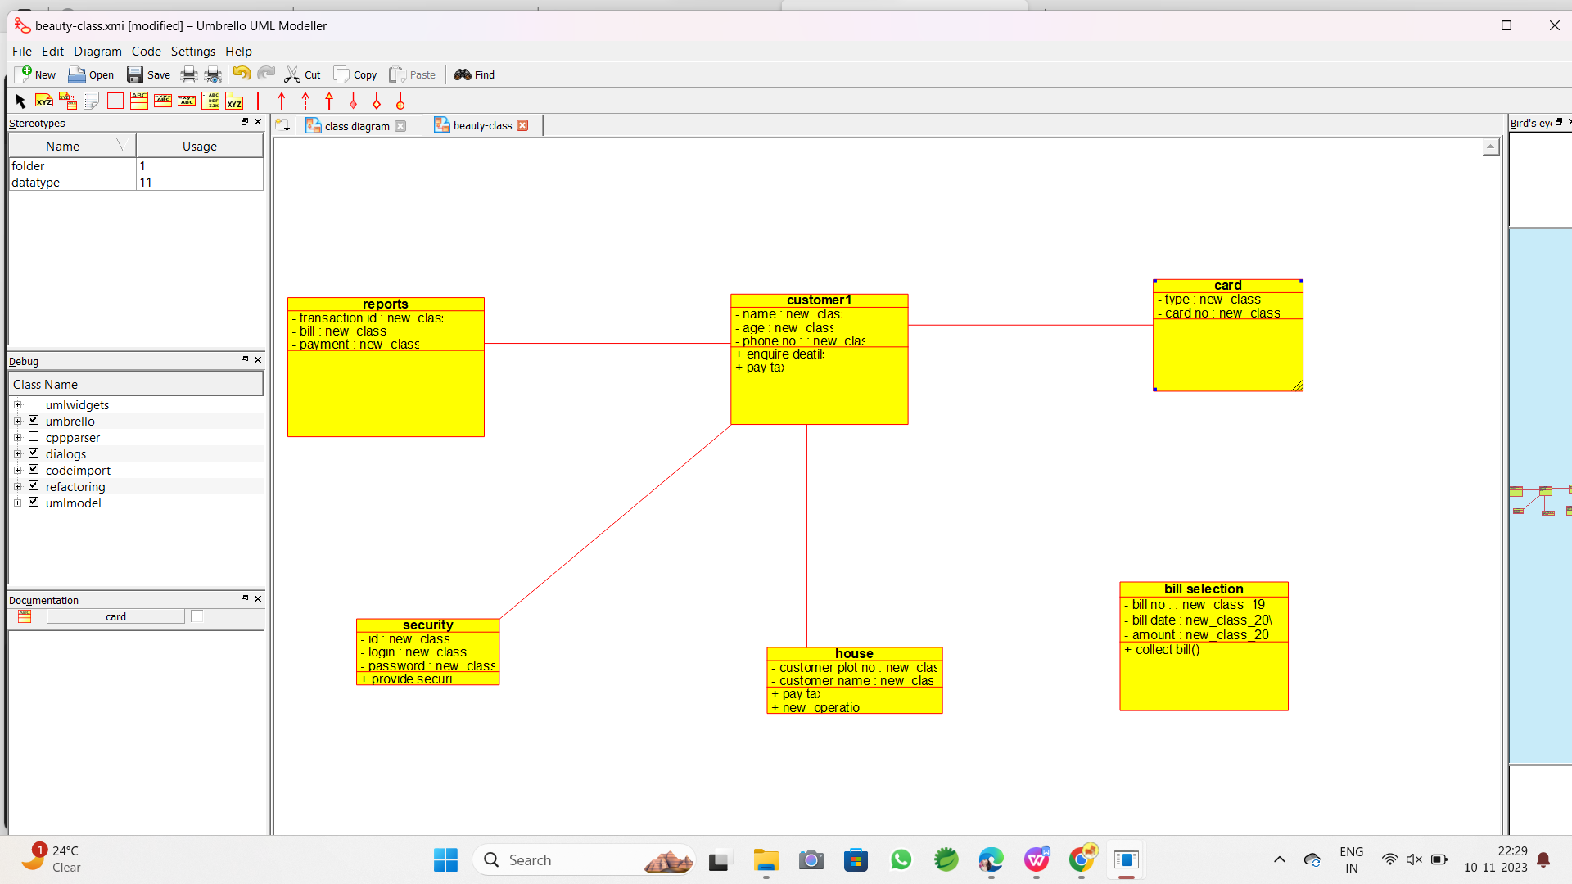

Use case diagram :

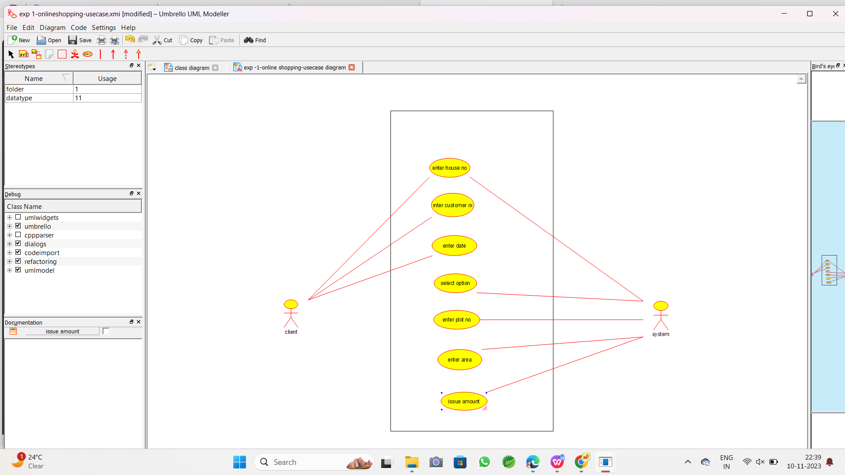

Deployment diagram :

